Revive a Romotive Romo Robot.

Sep 4, 2018.

Recently I bought a Romotive Romo Robot on eBay, it was listed as a Pololu Tracked Vehicle Robot (which of course I knew it wasn’t).

I paid $10.50 for it and another $7 for shipping. At the time I wasn’t sure what it was, but thought at least I’ll have a nice cassis, motors, and tracks - I could see the board and battery in the case as well, but couldn’t tell what it was.

eBay Pictures:

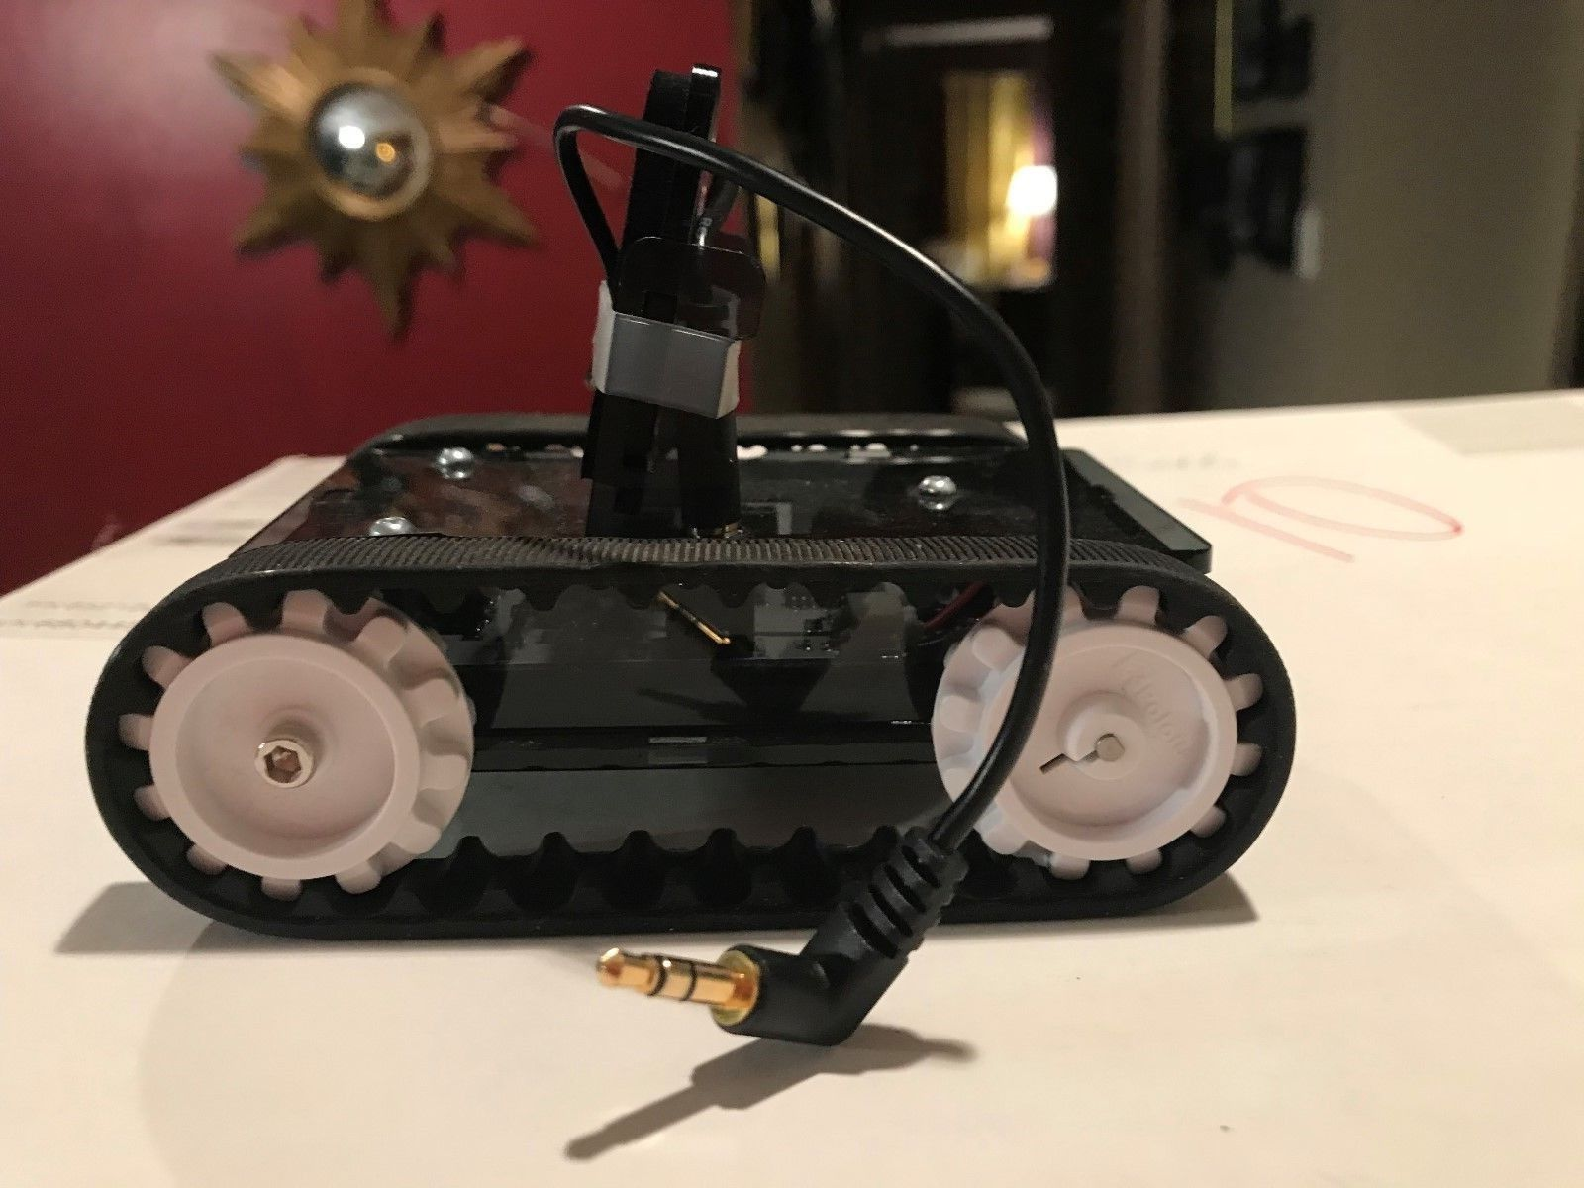

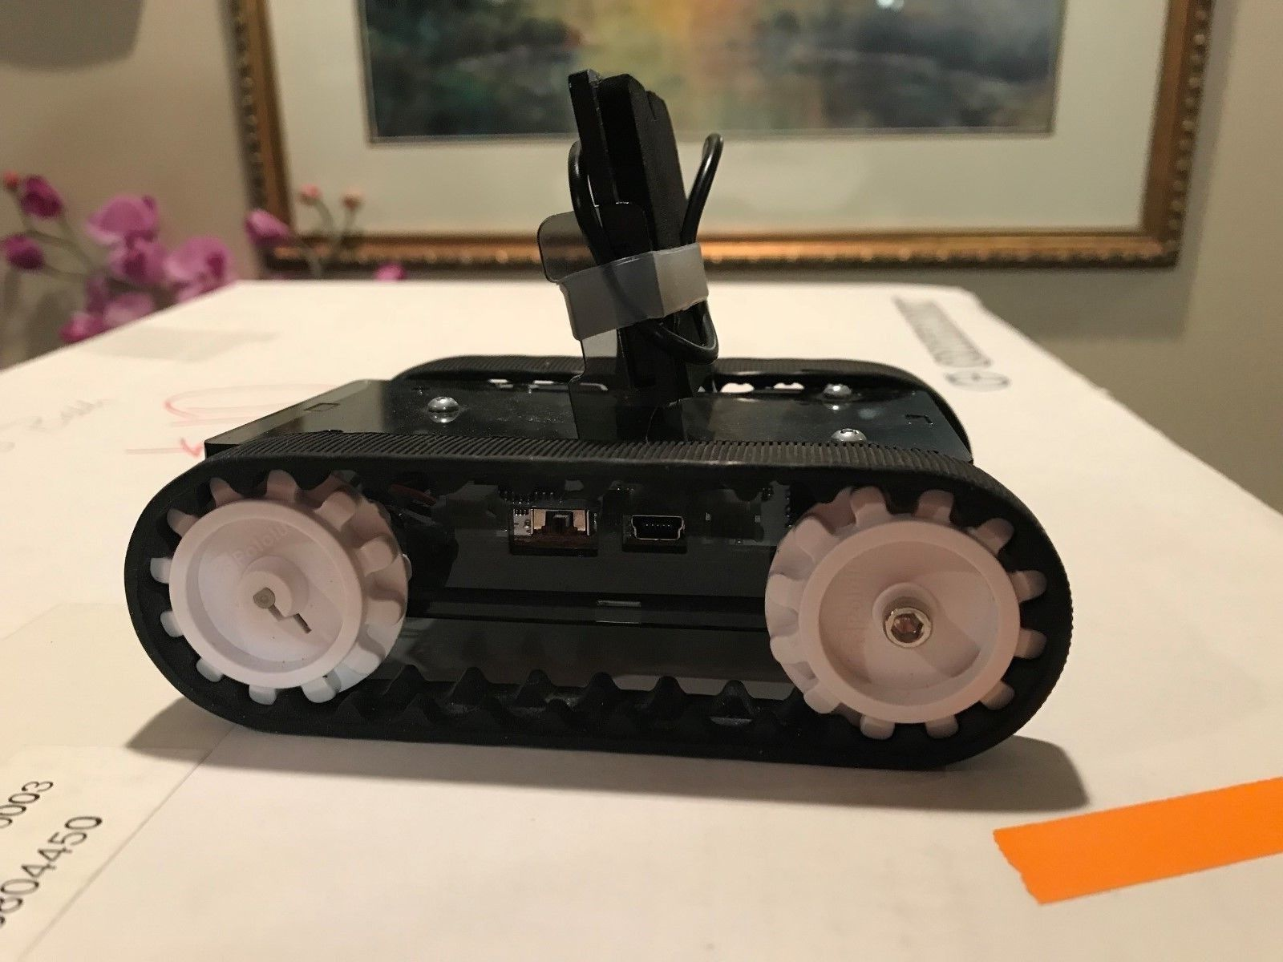

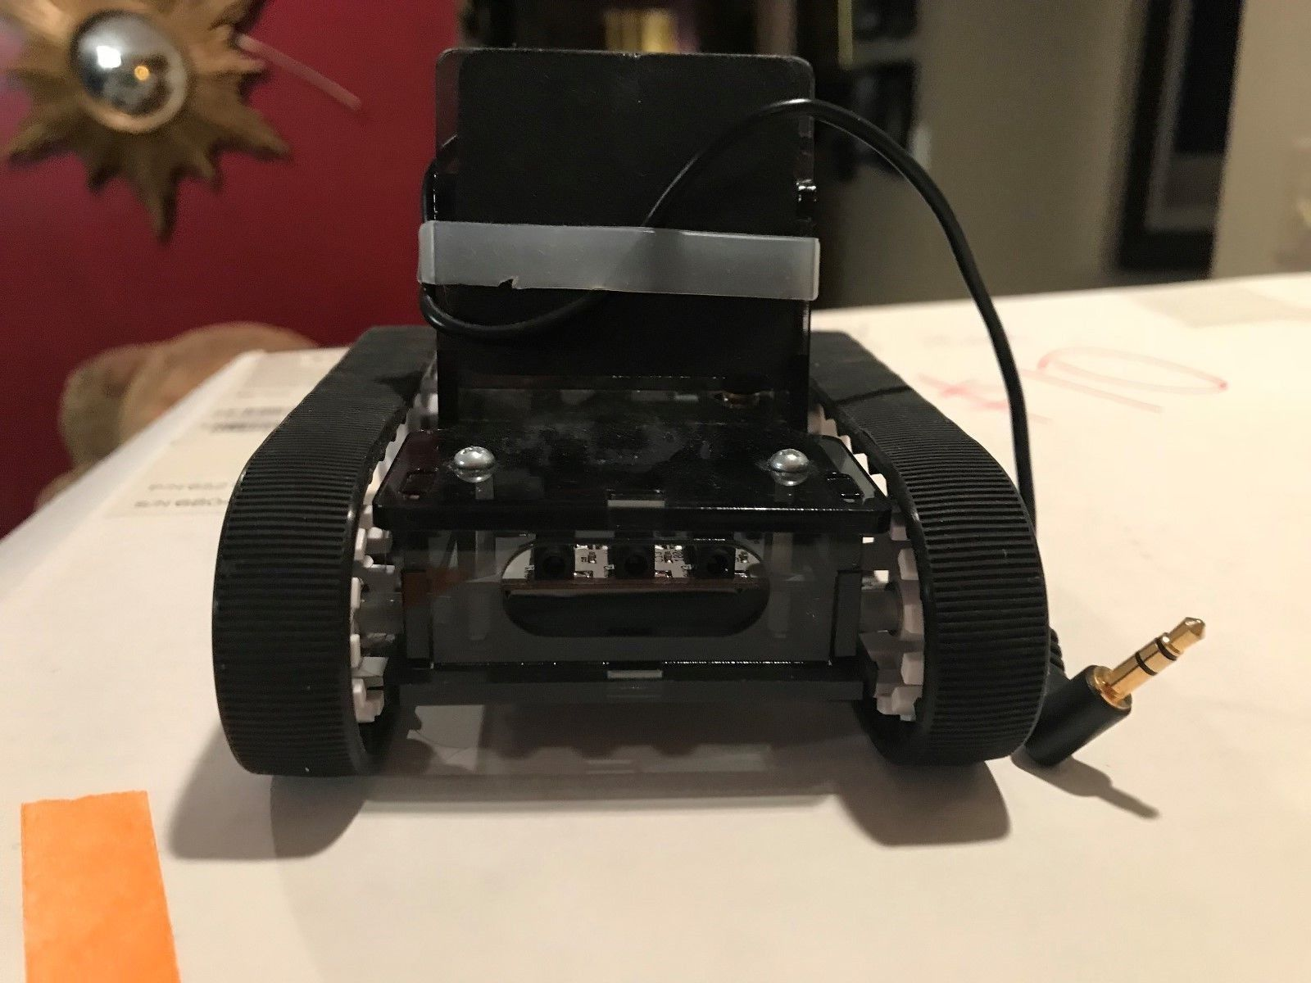

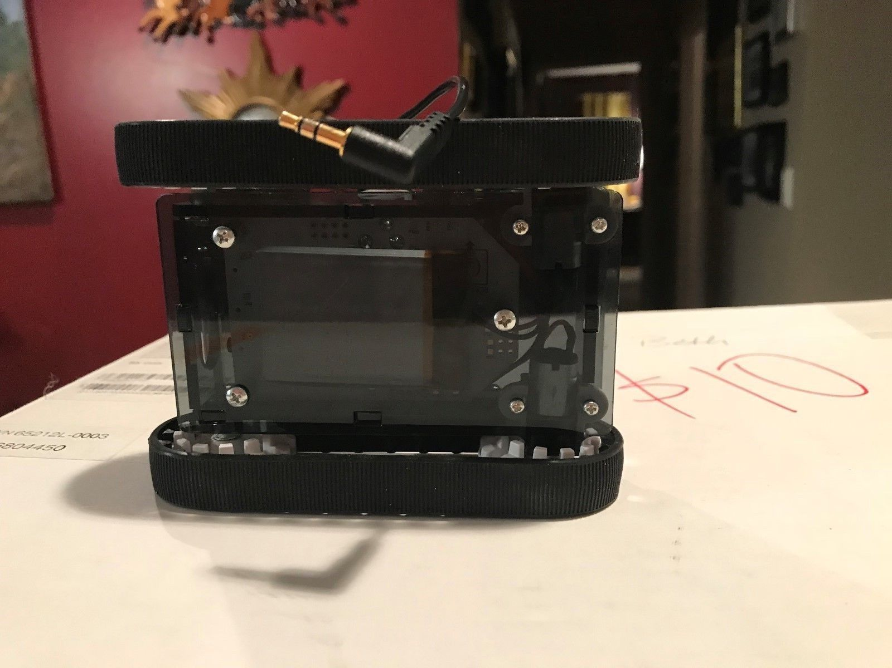

Mid-way from the time I placed my bid, and the time it ended I thought I’d google “tracked pololu robot” and started to look at pictures of what came up. Romo was one of those robots.

I quickly realized that is what I bid on.

The good news (or so I thought) Romo was opened sources (at least version 2 was).

The bad news is Romotive went out of business years ago, and even pulled the github repository for the robot. This is bad news, as there is little to no information about how to make it work. Even the IOS app was pulled from the app store recently. The Android app was/is vaporware (promised but never delivered).

As I understand it Romotive had a lot of issues with the robot working in the UK, and never delivered a complete working robot at least in the UK. They promised a lot and couldn’t make it work.

Looking at some of the archived information I found, they did release an SDK, but not a whole lot more, they were “hacker” friendly, but didn’t give a lot of the information needed (promises promises)

I was able to find a couple of people who did hack it and put there own firmware on it. And even someone who make it work with a Raspberry PI. So I thought, ok, I might still be able to do something with this.

Long story short this will be my journey into getting this to work with the Arduino IDE, or with the raspberry pi with the firmware that is on it (I’m not sure which I want to do) The original firmware is lost and if I choose to put my own on it I’ll probably never be able to control it witht he PI.

Here is some information I found:

<https://github.com/gcapiel/pi_romo> (I’m not sure this will work any more, and I’m not sure which firmware version is currently on the romo I have, so I might try this just to see, and decide what to do from that point).

Web Archive for some information that was saved by the Internet Archive.

<https://web.archive.org/web/20131212193628/http://romotive.com/developers/quickstart>

Limited information about the motor pins, and some other pins (Both sites are little different, but contain more or less the same information)

<https://electronics.stackexchange.com/questions/29283/how-is-this-motor-on-a-romotive-controlled>

<http://romotive.blogspot.com/>

Just some general information:

<https://www.cnx-software.com/2011/11/24/romo-robot-controlled-by-android-or-ios-smartphones/>

From this point on this will be my journey into this little robot: